**SMART STREET LIGHT SYSTEM**

***An industry oriented mini project report submitted***

***In partial fulfillment of the requirement for the award of the degree of***

**BACHELOR OF TECHNOLOGY**

in

**COMPUTER SCIENCE AND ENGINEERING**

*by*

**Vusirikala Hari Kiran(15131A05M4)**

**Yaswanth Sai Pulavarthi(15131A05N0)**

**Vaddi Siri Varsini(15131A05L3)**

**Rongala Surya Sai Teja(15131A05I2)**

*Under the esteemed guidance of*

**Ms. Lateefa Shaik**

**M.Tech, Assistant Professor**



**DEPARTMENT OF COMPUTER SCIENCE AND ENGINEERING**

GAYATRI VIDYA PARISHAD COLLEGE OF ENGINEERING(A)

(AFFILIATED TO JNTU, KAKINADA, AP)

VISAKHAPATNAM – 530048

2014 – 2017



**DEPARTMENT OF COMPUTER SCIENCE AND ENGINEERING**

GAYATRI VIDYA PARISHAD COLLEGE OF ENGINEERING(A)

(AFFILIATED TO JNTU, KAKINADA, AP)

VISAKHAPATNAM – 530048

**CERTIFICATE**

This is to certify that the project work entitled “**SMART STREET LIGHT SYSTEM**” being submitted by Vusirikala Hari Kiran(15131A05M4),Yaswanth Sai Pulavarthi (15131A05N0), Rongala Surya Sai Teja (15131A05I2), Vaddi Siri Varshini(15131A05L3) in partial fulfillment of the requirement the award of the degree of “Bachelor of technology” in Computer Science and Engineering is a record of bonafide work done by them under my supervision during the academic year 2018.

**Internal guide Head of the Department**

**Ms.Lateefa Shaik Dr.P.Krishna Subba Rao**

**M.Tech, Assistant Professor Professor & Head of Department CSE**

**GVPCOE(A) GVPCOE(A)**

**DECLARATION**

We hereby declare that this is a dissertation of our own work except where specifically ask to the contrary and it is not substantially the same as any dissertation which has been submitted to any university.

**By**

**Vusirikala Hari Kiran(15131A05M4)**

**Yaswanth Sai Pulavarthi(15131A05N0)**

**Vaddi Siri Varsini(15131A05L3)**

**Rongala Surya Sai Teja(15131A05I2)**

**ACKNOWLEDGEMENT**

We thank **Prof. A.B.K.Rao** principal, **Gayatri Vidya Parishad College of Engineering(A)**  for extending his utmost support and cooperation in providing all the provisions for the successful completion of the project.

We consider it our privilege to express our deepest gratitude to **Dr.P.K.Subba Rao** Professor, Head of the Department, Computer Science and Engineering, for his valuable suggestions and constant motivation that greatly helped the project work to get successfully completed.

(Thank your guide here)

We also thank all the members of the staff in Computer Science Engineering for their sustained help in our pursuits.

We thank all those who contributed directly or indirectly in successfully carrying out his work.

**By,**

**Vusirikala Hari Kiran(15131A05M4)**

**Yaswanth Sai Pulavarthi(15131A05N0)**

**Vaddi Siri Varsini(15131A05L3)**

**Rongala Surya Sai Teja(15131A05I2)**

SMART STREET LIGHT SYSTEM

Abstract

**ABSTRACT**

We need to save or conserve energy because most of the energy sources we depend on like coal and natural gas can’t be replaced if once we use them up they are gone forever. Saving power is very important instead of using the power in unnecessary times it should be switched off. In any city, “STREETLIGHT” is one of the major power consuming factors. Most of the time we see street lights are ON even after sunrise thus wasting a lot of energy.Here we are avoiding this problem by having a smart street light system which turns ON&OFF the street light varying intensity of light by the intensity of the light and the vehicles more on road using sensors.

Index

**INDEX**

pageno

1. ABOUT THE PROJECT…………………………………………...... 11

2. PROJECT SCOPE………………………………………………… … 13

2.1 EXISTING SYSTEM………………………………………….. 14

2.2 PROPOSED SYSTEM………………………………………… 14

3. FEASIBILTY REPORT……………………………………………… 15

3.1 TECHNICAL DESCRIPTION………………………………… 16

3.2 REQUIRED HARDWARE……………………………………… 16

3.3 REQUIRED SOFTWARE……………………………………… 16

3.4 FEASIBILITY TYPES………………………………………… 23

4. ANALYSIS…………………………………………………………… 25

4.1 SRS DOCUMENT……………………………………………… 26

4.2 SCOPE OF DEVELOPMENT………………………………… 26

5. DESIGN…………………………………………………………… 28

5.1 UML SPECIFICATIONS……………………………………… 29

5.2 SEQUENCE DIAGRAM………………………………………… 29

5.3 CLASS DIAGRAM……………………………………………… 30

5.4 ACTIVITY DIAGRAM………………………………………… 30

6. CODING……………………………………………………………… 32

6.1 SAMPLE CODE………………………………………………… 36

7. TESTING………………………………………………………………. 37

8. CONCLUSION………………………………………………………… 39

9. BIBLIOGRAPHY ……………………………………………………… 41

9.1 REFERENCES………………………………………………… 42

9.2 LIST OF WEBSITES…………………………………………… 42

About The Project

**1. ABOUT THE PROJECT**

A significant portion of the national electricity production goes to street lighting. We often find street lights ON during the day time and OFF during the night. Imagine thousands of street lights consuming thousands of watts, wasting away precious electricity. We need to save or conserve energy because most of the energy sources we depend on like coal and natural gas can’t be replaced if once we use them up they are gone forever. Saving power is very important instead of using the power in unnecessary times it should be switched off. In any city, “STREETLIGHT” is one of the major power consuming factors. Most of the time we see street lights are ON even after sunrise thus wasting a lot of energy.Here we are avoiding this problem by having a smart street light system which turns ON&OFF the street light varying intensity of light by the intensity of the light and the vehicles more on road using sensors.

Project Scope

**2. PROJECT SCOPE**

**2.1 Existing System :**

* Street Lights working in unnecessary times.
* Lot of energy consumption.
* Not very efficient and optimized.
* Manual switching.
* Astronomical Timers.

**2.2 Problems in the Existing System :**

* We often find street lights ON during the day time and OFF during the night.

**Proposed System :**

* Automation, Power consumption and Cost Effectiveness are the important considerations in the present field of electronics and electrical related technologies.
* The aim of automated streetlight management system using IOT is the conservation of energy by reducing electricity wastage.
* The above existing problems can be solved by replacing existing lamps with light-emitting diode (LED) lamps and making the street lights ‘smarter’ using some sensors.
* Street lights will work only when vehicles pass on through the street lights using IR sensor.
* This whole system will work only in the absence of sunlight making use of the LDR sensor.
* Initially the street lights will work with certain intensity of light which can be fixed.
* When the vehicles pass on the street lights glow with maximum intensity.
* In this system the street lights at the turnings are always made glow with max intensity to decrease the road accidents while making the turnings.

Feasibility Report

**3. Feasibility Report**

**3.1 Technical Description:**

This project have components mainly sensors LDR and IR which are not more costlier and more effortable. This project is feasible with the present world as we need to conserve the electricity lot. Present we have lot of electrical applications, so we need to conserve electricity.

**GUI’s**

**1). Arduino IDE**

**3.2 REQUIRED HARDWARE:**

Hardware requirements

* Cable
* Wires
* LED lamps
* IR sensor
* Arduino UNO
* Jumper wire
* LDR
* Resistors

**3.3 REQUIRED SOFTWARE :**

Software requirements

* Arduino IDE

**IR sensors:**

**Infrared Obstacle Sensor Module** has builtin **IR transmitter** and **IR receiver** that sends out IR energy and looks for reflected IR energy to detect presence of any obstacle in front of the sensor module. The module has on board potentiometer that lets user adjust detection range. The sensor has very good and stable response even in ambient light or in complete darkness.

**Specifications**

* Operating Voltage:**3.0V – 5.0V**
* Detection range:**2cm – 30cm (Adjustable using potentiometer)**
* Current Consumption:**at 3.3V : ~23 mA**,**at 5.0V: ~43 mA**
* Active output level: **Outputs Low logic level when obstacle is detected**
* On board Obstacle Detection LED indicator

**Working Principle of IR Obstacle Sensor**

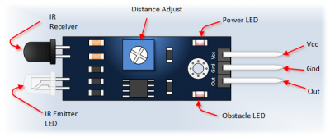

An IR sensor consists of an IR LED and an IR Photodiode; together they are called as Photo–Coupler or Opto–Coupler. As said before,the Infrared Obstacle Sensor has builtin IR transmitter and IR receiver.**Infrared Transmitter** is a light emitting diode (LED) which emits infrared radiations. Hence, they are called IR LED’s. Even though an IR LED looks like a normal LED, the radiation emitted by it is invisible to the human eye. **Infrared receivers** are also called as infrared sensors as they detect the radiation from an IR transmitter. IR receivers come in the form of photodiodes and phototransistors. Infrared Photodiodes are different from normal photo diodes as they detect only infrared radiation. When the IR transmitter emits radiation, it reaches the object and some of the radiation reflects back to the IR receiver. Based on the intensity of the reception by the IR receiver, the output of the sensor is defined.

**Connection of IR Obstacle Sensor to Arduino Uno:-**

**Hardware and Software Required**

* IR Obstacle Sensor Module
* Arduino Uno
* Arduino IDE(1.0.6V)

**Hardware Connections**

* Vcc to 5V
* Gnd to Gnd
* Out to digital pin 7

**LDR sensors:**

A **photoresistor** (or **light-dependent resistor**, **LDR**, or **photo-conductive cell**) is a light-controlled variable resistor. The resistance of a photoresistor decreases with increasing incident light intensity; in other words, it exhibits photoconductivity. A photoresistor can be applied in light-sensitive detector circuits, and light-activated and dark-activated switching circuits.

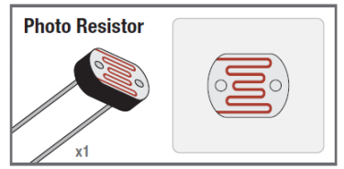

**Jumper Wires:**

A **jump wire** (also known as jumper, jumper wire, jumper cable, DuPont wire, or DuPont cable – named for one manufacturer of them) is an electrical wire, or group of them in a cable, with a connector or pin at each end (or sometimes without them – simply "tinned"), which is normally used to interconnect the components of a breadboard or other prototype or test circuit, internally or with other equipment or components, without soldering

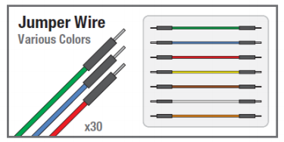

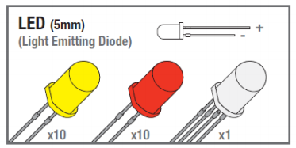

**Resistor:**

A resistor is a passive two terminal electrical component that implements electrical resistance as a circuit element. In electronic circuit, resistors are used to limit current flow, to adjust signal levels, bias active elements, and terminate transmission line among other uses. High power resistors, that can dissipate many watts of electrical power as heat, may be used as part of motor controls, in power distribution systems, or as test loads for generators. Fixed resistors have resistances that only change slightly with temperature, time or operating voltage. Variable resistors can be used to adjust circuit elements, or as sensing devices for heat, light, humidity, force, or chemical activity.

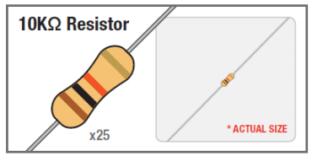

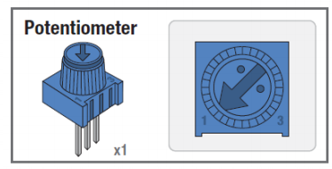

**Arduino:**

**Overview**

The Arduino Uno is a microcontroller board based on the ATmega328 (datasheet). It has 14 digital input/output pins (of which 6 can be used as PWM outputs), 6 analog inputs, a 16 MHz ceramic resonator, a USB connection, a power jack, an ICSP header, and a reset button. It contains everything needed to support the microcontroller; simply connect it to a computer with a USB cable or power it with a AC-to-DC adapter or battery to get started.

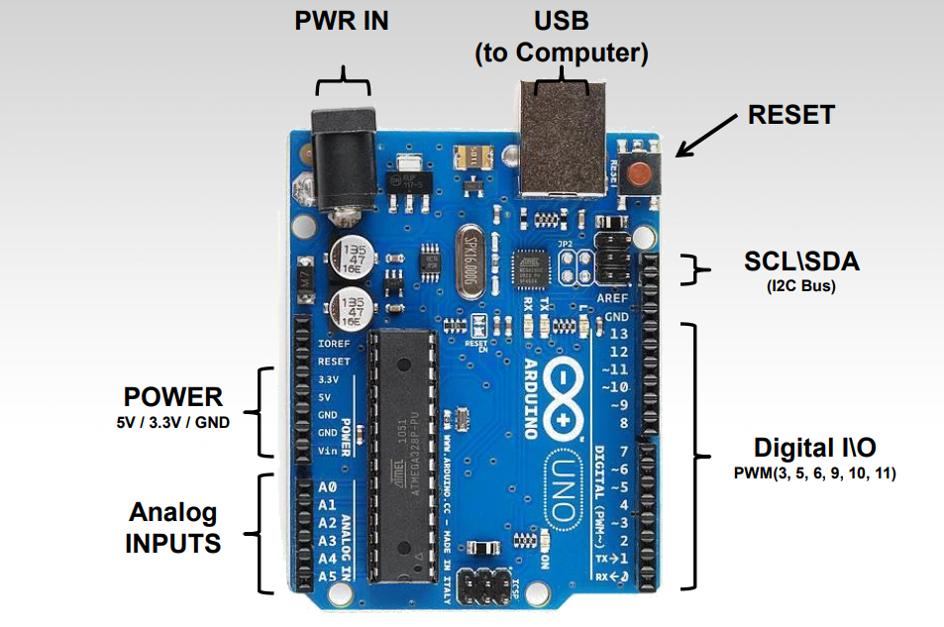

**Summary**

Microcontroller ATmega328

Operating Voltage 5V

Input Voltage (recommended) 7-12V

Input Voltage (limits) 6-20V

Digital I/O Pins 14 (of which 6 provide PWM output)

Analog Input Pins 6

DC Current per I/O Pin 40 mA

DC Current for 3.3V Pin 50 mA

Flash Memory 32 KB (ATmega328) of which 0.5 KB used by

bootloader

SRAM 2 KB (ATmega328)

EEPROM 1 KB (ATmega328)

Clock Speed 16 MHz

**Power**

The Arduino Uno can be powered via the USB connection or with an external power supply. The power source is selected automatically.

External (non-USB) power can come either from an AC-to-DC adapter (wall-wart) or battery. The adapter can be connected by plugging a 2.1mm center-positive plug into the board's power jack. Leads from a battery can be inserted in the Gnd and Vin pin headers of the POWER connector. The board can operate on an external supply of 6 to 20 volts. If supplied with less than 7V, however, the 5V pin may supply less than five volts and the board may be unstable. If using more than 12V, the voltage regulator may overheat and damage the board. The recommended range is 7 to 12 volts. The power pins are as follows:

* **VIN**. The input voltage to the Arduino board when it's using an external power source (as opposed to 5 volts from the USB connection or other regulated power source). You can supply voltage through this pin, or, if supplying voltage via the power jack, access it through this pin.
* **5V**.This pin outputs a regulated 5V from the regulator on the board. The board can be supplied with power either from the DC power jack (7 - 12V), the USB connector (5V), or the VIN pin of the board (7-12V). Supplying voltage via the 5V or 3.3V pins bypasses the regulator, and can damage your board. We don't advise it.
* **3V3**. A 3.3 volt supply generated by the on-board regulator. Maximum current draw is 50 mA.
* **GND**. Ground pins.

**Memory**

The ATmega328 has 32 KB (with 0.5 KB used for the bootloader). It also has 2 KB of SRAM and 1 KB of EEPROM (which can be read and written with the EEPROM library).

**Input and Output**

Each of the 14 digital pins on the Uno can be used as an input or output, using pinMode(), digitalWrite(), and digitalRead() functions. They operate at 5 volts. Each pin can provide or receive a maximum of 40 mA and has an internal pull-up resistor (disconnected by default) of 20-50 kOhms. In addition, some pins have specialized functions:

* **Serial: 0 (RX) and 1 (TX)**. Used to receive (RX) and transmit (TX) TTL serial data. These pins are connected to the corresponding pins of the ATmega8U2 USB-to-TTL Serial chip.
* **External Interrupts: 2 and 3**. These pins can be configured to trigger an interrupt on a low value, a rising or falling edge, or a change in value. See the attachInterrupt() function for details.
* **PWM: 3, 5, 6, 9, 10, and 11**. Provide 8-bit PWM output with the analogWrite() function.
* **SPI**: 10 (SS), 11 (MOSI), 12 (MISO), 13 (SCK). These pins support SPI communication using the SPI library.
* **LED: 13**. There is a built-in LED connected to digital pin 13. When the pin is HIGH value, the LED is on, when the pin is LOW, it's off.

The Uno has 6 analog inputs, labeled A0 through A5, each of which provide 10 bits of resolution (i.e. 1024 different values). By default they measure from ground to 5 volts, though is it possible to change the upper end of their range using the AREF pin and the analogReference() function. Additionally, some pins have specialized functionality:

* **TWI: A4 or SDA pin and A5 or SCL pin**. Support TWI communication using the Wire library.

There are a couple of other pins on the board:

* **AREF**. Reference voltage for the analog inputs. Used with analogReference().
* **Reset**. Bring this line LOW to reset the microcontroller. Typically used to add a reset button to shields which block the one on the board.

**3.4 FEASIBILITY TYPES:**

**Technical feasibility:**

The technical issue usually raised during the feasibility stage of the investigation includes the following:

* This project is the necessary technology suggested.
* The proposed equipments have the technical capacity to hold the data required to use the new system.
* The proposed system provide adequate response to inquiries, regardless of the number or location of users.
* The system can be upgraded if developed.
* This technically guarantees the accuracy, reliability, ease of access and data security.

The system is self-explanatory and does not need any extra sophisticated training. As the system has been built by concentrating on the Graphical User Interface Concepts, the application can also be handled very easily with a nowise User.

The system has been added with features of menu driven and touch interaction methods, which makes the user the master as he/she starts working through the environment. The net time the customer should concentrate is on the installation time.

**Financial Feasibility:**

The system as a whole sees a very highly integrated time saving construct and is compatible. As the application gets integrated with the Arduino ,the user can easily handle light intensity when to work.

Analysis

Report

**4. ANALYSIS Report**

**4.1 SRS(Software Requirements Specification) DOCUMENT**

The basic software requirements specification of the system is we need to supply power to the arduino. The code is dumped to arduino and no need to computer or dumping every time. We can dump new code when need any changes.

The document is prepared keeping is view of the academic constructs of my Bachelors Degree from university as partial fulfillment of my academic purpose the document specifies the general procedure that that has been followed by me, while the system was studied and developed. The general document was provided by the industry as a reference guide to understand my responsibilities in developing the system, with respect to the requirements that have been pin pointed to get the exact structure of the system as stated by the actual client.

The system as stated by my project leader the actual standards of the specification were desired by conducting a series of interviews and questionnaires. The collected information was organized to form the specification document and then was modeled to suite the standards of the system as intended.

**Document Conventions:**

The overall documents for this project use the recognized modeling standards at the software industries level.

1. The Physical dispense, which state the overall data search for the relational key whereas a transaction is implemented on the wear entities.
2. Unified modeling language concepts to give a generalized blue print for the overall system.
3. The standards of flow charts at the required states that are the functionality of the operations need more concentration.

**4.2 SCOPE OF DEVELOPMENT**

**Future scope:**

This project has scope for improvement and many enhancements can be done to make it more reliable and interesting. For example, when a vehicle or a person meet with an accident street light remains on, a system can be introduced to inform the respective authorities. Similarly, a system can be introduced to inform the technicians about the default.

Design

Document

**5. Design Document**

**5.1 Unified Modeling Language Specifications**

**UML:**

**USECASEDIAGRAM :** 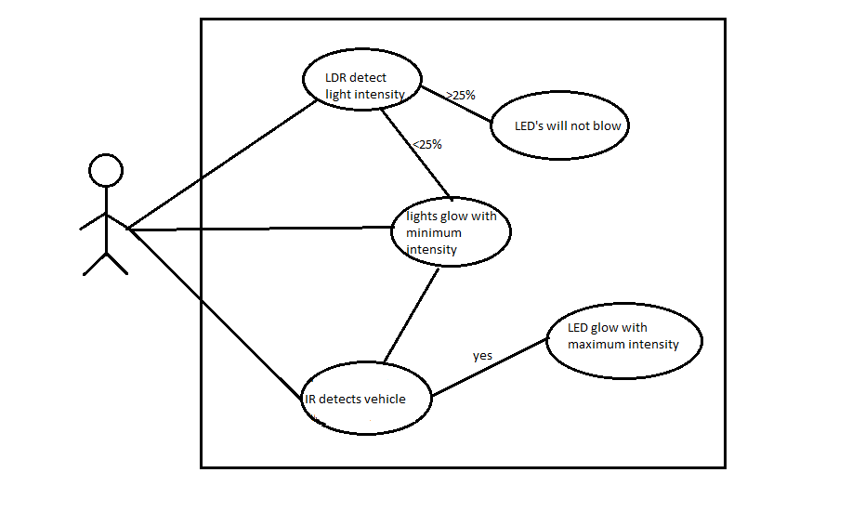

**5.2.SEQUENCE DIAGRAM :**

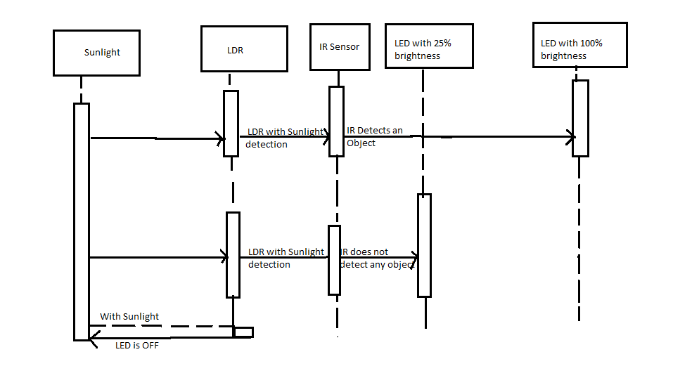**5.3 CLASS DIAGRAM :**

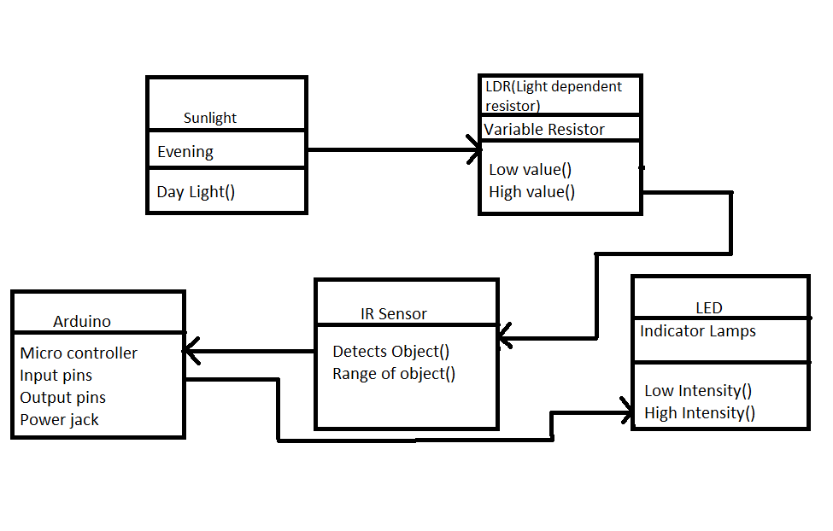

**5.4 ACTIVITY DIAGRAM:**

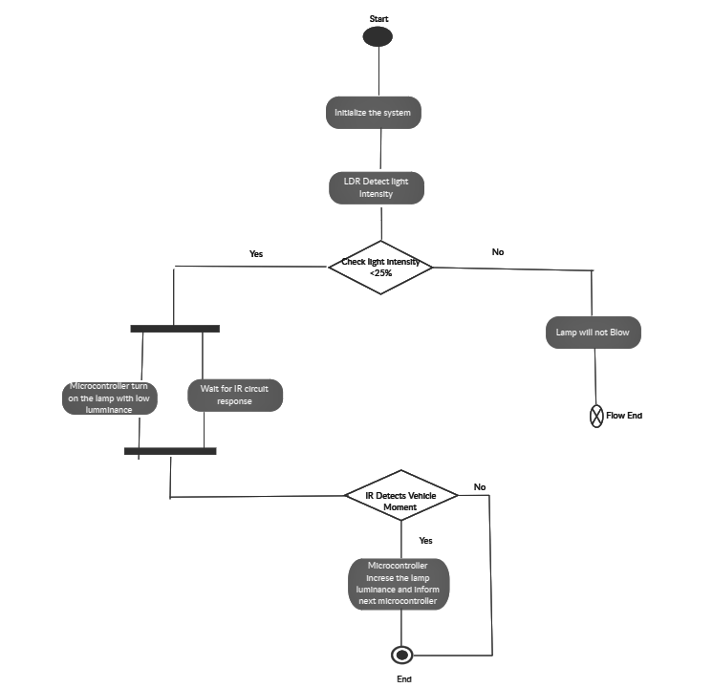

Coding

**6. CODING**

**Arduino Code.ino :**

int led1 = 3;

int led2 = 10;

int led3 = 5;

int led4 = 6;

int led5 = 9;

int ldr = A0;

int ir1 = A1;

int ir2 = A2;

int ir3 = A3;

int ir4 = A4;

int ir5 = A5;

void setup() {

Serial.begin(9600);

pinMode(led1, OUTPUT);

pinMode(led2, OUTPUT);

pinMode(led3, OUTPUT);

pinMode(led4, OUTPUT);

pinMode(led5, OUTPUT);

pinMode(ldr, INPUT);

pinMode(ir, INPUT);

pinMode(ir1, INPUT);

pinMode(ir2, INPUT);

pinMode(ir3, INPUT);

pinMode(ir4, INPUT);

}

void loop() {

Serial.println(analogRead(A0));

int ldrStatus = analogRead(ldr);

if (ldrStatus <= 300) {

digitalWrite(led, HIGH);

analogWrite(led, 255 / 5);

digitalWrite(led1, HIGH);

analogWrite(led1, 255 / 5);

digitalWrite(led2, HIGH);

analogWrite(led2, 255 / 5);

digitalWrite(led3, HIGH);

analogWrite(led3, 255 / 5);

digitalWrite(led4, HIGH);

analogWrite(led4, 255 / 5);

if (analogRead(ir1) <=40) {

digitalWrite(led1, HIGH);

delay(1000);

}

if (analogRead(ir2) <=40) {

digitalWrite(led2, HIGH);

delay(1000);

}

if (analogRead(ir3) <=40) {

digitalWrite(led3, HIGH);

delay(1000);

}

if (analogRead(ir4) <=40) {

digitalWrite(led4, HIGH);

delay(1000);

}

if (analogRead(ir5) <=40) {

digitalWrite(led5, HIGH);

delay(1000);

}

} else {

digitalWrite(led, LOW);

digitalWrite(led1, LOW);

digitalWrite(led2, LOW);

digitalWrite(led3, LOW);

digitalWrite(led4, LOW);

}

}

Testing

**7. TESTING**

**Testing :**

The testing of system is check whether LDR is working fine as when the system even on day lights

Purpose of Testing:

The Purpose of testing is to make the IR sensor sent the range to detect the object.

Testing Objectives :

To make the system work for all conditions.

**7.1 Levels of Testing**

In order to uncover the errors present in different phases we have the concept of levels of testing. The basic levels of testing are as shown below…

Code Testing

The code is tested in Arduino IDE setting the ports, and board.

CONCLUSION

**8.CONCLUSION**

* In coming days this will prove a great boon to the country since it will save lot of electricity of power plant that gets wasted in illuminating the street lights.
* As a conclusion around 80% of power consumption can be reduced by using this system towards providing a solution for energy saving.

BIBLIOGRAPHY

**9. BIBLIOGRAPHY**

**9.1 REFERENCES**

* “Sensors and Signal Conditioning” by John G Webster
* “Sensors, Instrumentation and Special Topics” by Proulx
* “Measurement, Instrumentation, and Sensors Handbook” by Webster and Eren

**9.2 LIST OF WEBSITES:**

* <https://www.wikipedia.org>
* <https://www.arduino.cc/en/Main/Docs>
* <https://en.wikipedia.org/wiki/Photoresistor>
* <https://wiki.eprolabs.com/index.php?title=IR_Obstacle_Sensor>
* <https://en.wikipedia.org/wiki/Jump_wire>